Design Document: Customer Support Ticketing System

1. Project Overview
The Customer Support Ticketing System is a web-based platform that allows customers to submit support tickets and for support staff to manage these tickets. The system will support ticket creation, status updates, and resolutions, with notifications for both customers and support agents.

2. System Architecture
Architecture Type:
- Backend: ASP.NET Core 8 for the RESTful API.
- Frontend: Angular 18 for the user interface.
- Database: SQL Server using Entity Framework Core for data persistence.
- Microservices: Decomposed into services for ticket management, user management, and notifications.
- Containerization: Docker for containerizing the application.
- CI/CD Pipeline: Azure DevOps for continuous integration and deployment.
Deployment Strategy:
- The system will be containerized using Docker and deployed on Kubernetes for orchestration and scalability.
- Azure DevOps will be used to set up the CI/CD pipeline for automatic build, test, and deployment.

3. Functional Requirements
The application will have two main user roles:
- Customer: Can create support tickets, view ticket status, and communicate with support staff.
- Support Staff: Can view and manage tickets, update status, and resolve issues.
Features:
- Ticket Management:
- Create tickets: Customers can submit tickets with details such as issue description, priority, and category.
- Ticket status updates: Support staff can update the status (Open, In Progress, Resolved) and add comments.
- Ticket history: Display ticket history to both customers and support staff.
- Notifications:
- Notifications for customers and support staff when ticket status changes or new comments are added.
- Role-Based Access Control (RBAC):
- JWT-based authentication to manage access control for customers and support staff.

4. Non-Functional Requirements
- Scalability: The system should be scalable to accommodate multiple users and tickets.
- Security: JWT authentication and role-based access control (RBAC) will be enforced.
- Performance: The system should handle at least 100 concurrent users without significant delay.
- Reliability: The system should ensure reliable data storage and backup using Docker and Kubernetes for high availability.

5. Detailed Design

5.1 Frontend (Angular/React)
Technology Stack: Angular 18, Bootstrap for responsive design./React with Bootstrap
Angular
Folder Structure:
/src
/app
/components
/ticket-list
/ticket-create
/ticket-details
/services
/ticket.service.ts
/models
/ticket.model.ts
/modules
/customer.module.ts
/support.module.ts
/assets
/environments
React
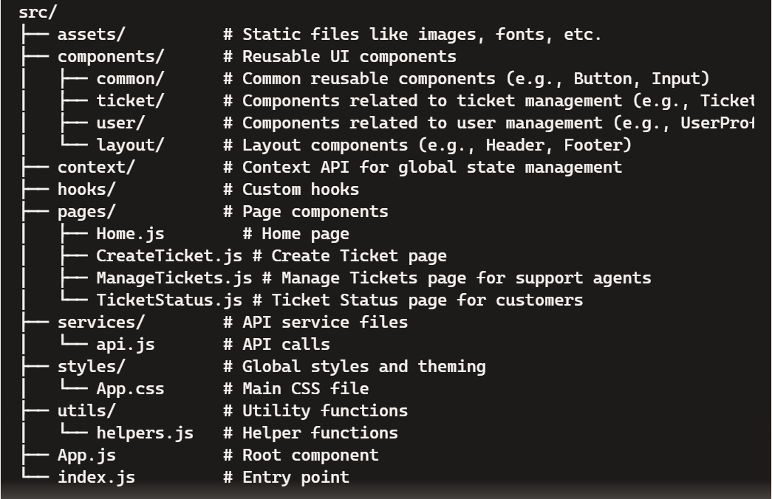
Components:
1. Ticket List Component: Displays all tickets for a customer or support staff in a paginated table. Allows filtering by status and priority.
2. Ticket Create Component: Form for customers to submit a new support ticket.
3. Ticket Details Component: Displays the ticket details, status, and comments. Allows support staff to update ticket status and add comments.

5.2 Backend (ASP.NET Core)
Technology Stack: ASP.NET Core 8, Entity Framework Core, SQL Server.
Folder Structure:
/src
/Controllers
TicketController.cs
UserController.cs
/Models
Ticket.cs
User.cs
/DTOs
TicketDTO.cs
UserDTO.cs
/Repositories
ITicketRepository.cs
IUserRepository.cs
/Services
TicketService.cs
/Data
AppDbContext.cs
/Migrations
Controllers:
- TicketController:
- GET /tickets: Retrieve all tickets for the current user (customer or support staff).
- POST /tickets: Submit a new ticket.
- PUT /tickets/{id}/status: Update the status of a ticket.
- PUT /tickets/{id}/comment: Add a comment to a ticket.
- UserController:
- POST /users/authenticate: Authenticate and login a user.
- GET /users/{id}: Retrieve user details.
Models:
- Ticket Model:
public class Ticket {
public int TicketId { get; set; }
public int UserId { get; set; }
public string Title { get; set; }
public string Description { get; set; }
public string Status { get; set; } // Open, In Progress, Resolved
public DateTime CreatedAt { get; set; }
public DateTime UpdatedAt { get; set; }
public List<Comment> Comments { get; set; }
}
- User Model:
public class User {
public int UserId { get; set; }
public string Name { get; set; }
public string Role { get; set; } // Customer, Support
public string Email { get; set; }
}

5.3 Database Design
- Ticket Table:
Columns: TicketId, UserId, Title, Description, Status, CreatedAt, UpdatedAt.
- User Table:
Columns: UserId, Name, Role, Email.
Entity Framework Core:
- The database will be managed using EF Core with migrations to keep track of schema changes.
- A code-first approach will be used for database design.

5.4 Containerization (Docker)
Dockerfile for Backend:
FROM mcr.microsoft.com/dotnet/aspnet:8.0 AS base
WORKDIR /app
EXPOSE 80
FROM mcr.microsoft.com/dotnet/sdk:8.0 AS build
WORKDIR /src
COPY . .
RUN dotnet restore
RUN dotnet build -c Release -o /app/build
FROM build AS publish
RUN dotnet publish -c Release -o /app/publish
FROM base AS final
WORKDIR /app
COPY --from=publish /app/publish .
ENTRYPOINT ["dotnet", "SupportTicketApp.dll"]
Docker Compose for Multi-container Setup:
version: '3.4'
services:
app:
image: support-ticket-app
build:
context: .
dockerfile: Dockerfile
ports:
- "8080:80"
db:
image: mcr.microsoft.com/mssql/server:2019-latest
environment:
SA_PASSWORD: "YourPassword123"
ACCEPT_EULA: "Y"
ports:
- "1433:1433"

5.5 CI/CD Pipeline (Azure DevOps)
Pipeline Steps:
1. Build Pipeline:
- Restore NuGet packages.
- Build the project.
- Run unit tests.
- Publish build artifacts.
2. Release Pipeline:
- Pull the latest build artifact.
- Deploy the Docker image to Azure Kubernetes Service (AKS).
YAML Pipeline:
trigger:
branches:
include:
- main
pool:
vmImage: 'ubuntu-latest'
steps:
- task: UseDotNet@2
inputs:
packageType: 'sdk'
version: '8.x'
- script: dotnet restore
displayName: 'Restore NuGet packages'
- script: dotnet build --configuration Release
displayName: 'Build solution'
- script: dotnet test
displayName: 'Run unit tests'
- task: PublishBuildArtifacts@1
inputs:
pathToPublish: $(Build.ArtifactStagingDirectory)

6. Testing Strategy
Unit Testing:
- Use xUnit for unit tests on both the backend services and repositories.
- Angular testing using Jasmine for testing components and services.
API Testing:
- Postman will be used to test the API endpoints.

7. Deployment Strategy
The application will be containerized and deployed using Docker and Kubernetes.
Azure DevOps will automate the build, test, and deployment processes using pipelines.

